**Credential Generation :**

1. 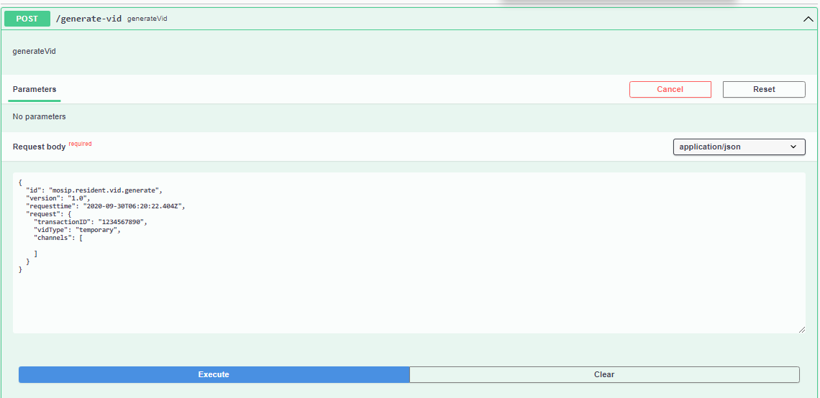Generate a credential.

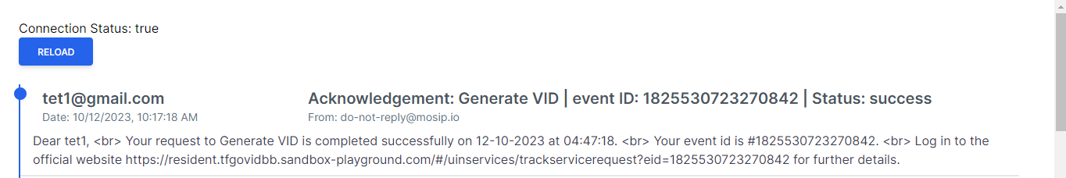Notification